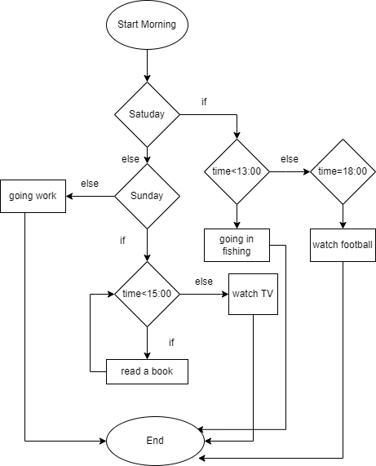**1. Draw flowchart**

Start Morning:

if Saturday:

if time < 13:00:

going in fishing:

else if time = 18:00

watch football:

else if Sunday:

while time < 15:00:

read a book:

else:

watch TV:

else:

going work:

End:

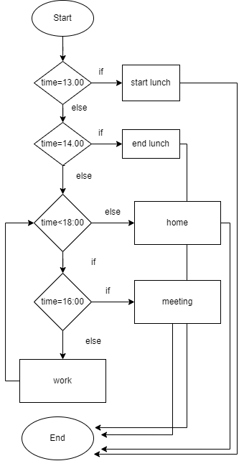

**2. Draw flowchart**

Start:

if time=13:00:

start lunch:

else if time = 14:00:

end lunch:

else:

while time<18:00

if time = 16:00:

meeting:

else:

work:

else:

home:

End:

**3.** **Create pseudocode**

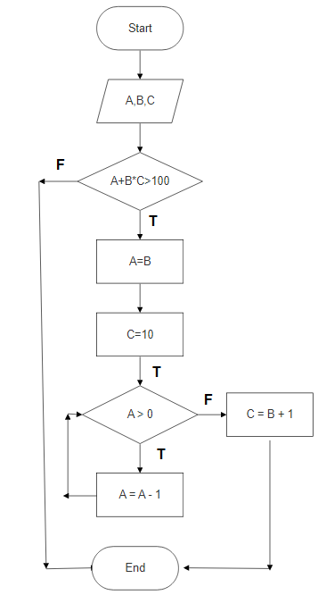  
Start

Input A, B, C

If A+B*C>100

Then A=B;

C=10:

While A>0

Then A=A-1

Else: C=B+1

End